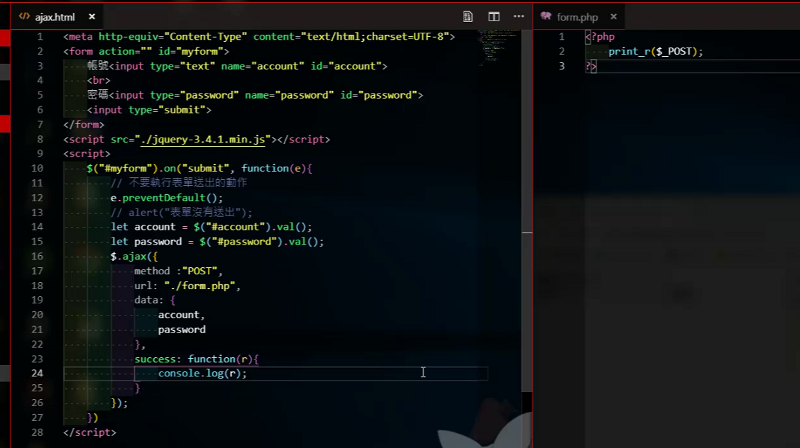

Ajax.html

<meta http-equiv="Content-Type" content="text/html;charset=UTF-8">

<form action="" id="myform">

帳號<input type="text" name="account" id="account">

<br>

密碼<input type="password" name="password" id="password">

<input type="submit" value="">

</form>

<script src="./jquery-3.4.1.min.js"></script>

<script>

$("#myform").on("submit", function(e){

//不要執行表單送出

e.preventDefault();

// alert("表單沒有送出");

let account = $("#account").val();

let password = $("#password").val();

$.ajax({

method:"POST",

url: "./form.php",

data: {

account,

password

},

success: function(r){

console.log(r);

}

});

})

</script>

Form.php

<?php

print_r($_POST);

?>

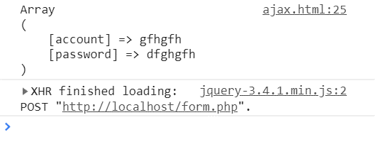

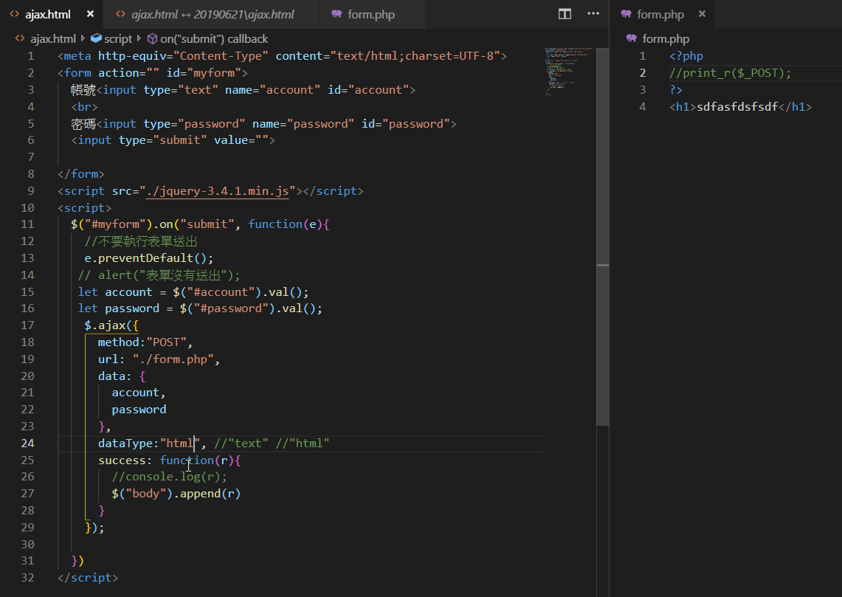

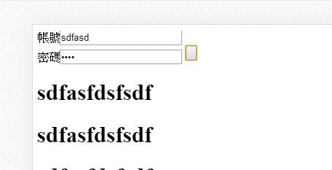

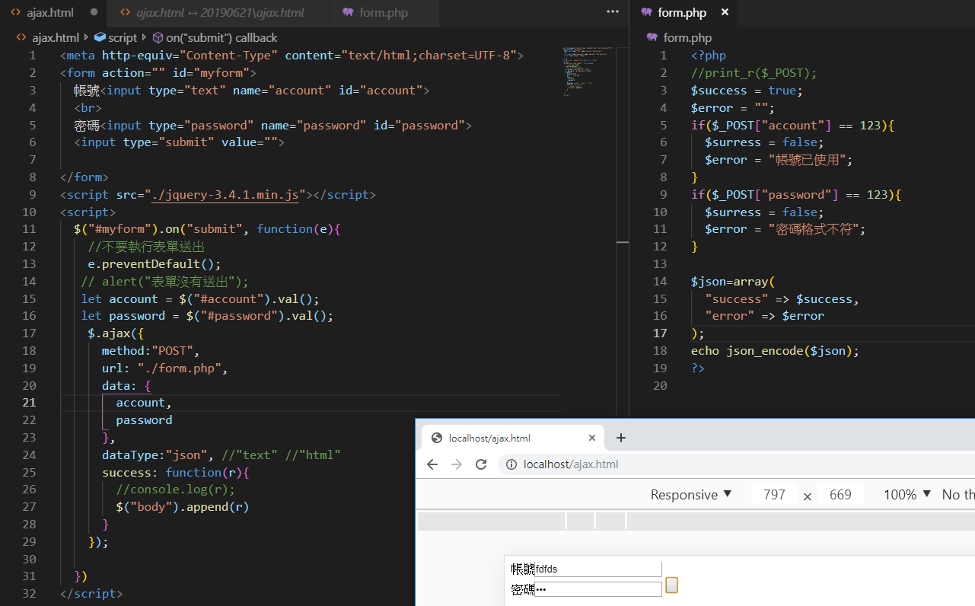

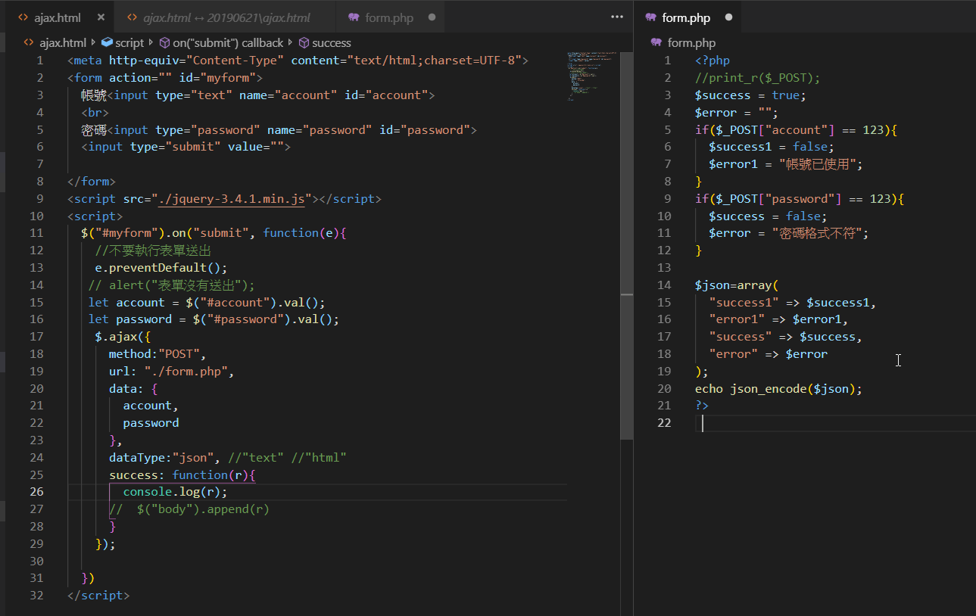

Aj 要debug的話,比較麻煩,需要將dataType改為text

dataType:"json", //"text" //"html"

r代表整個json

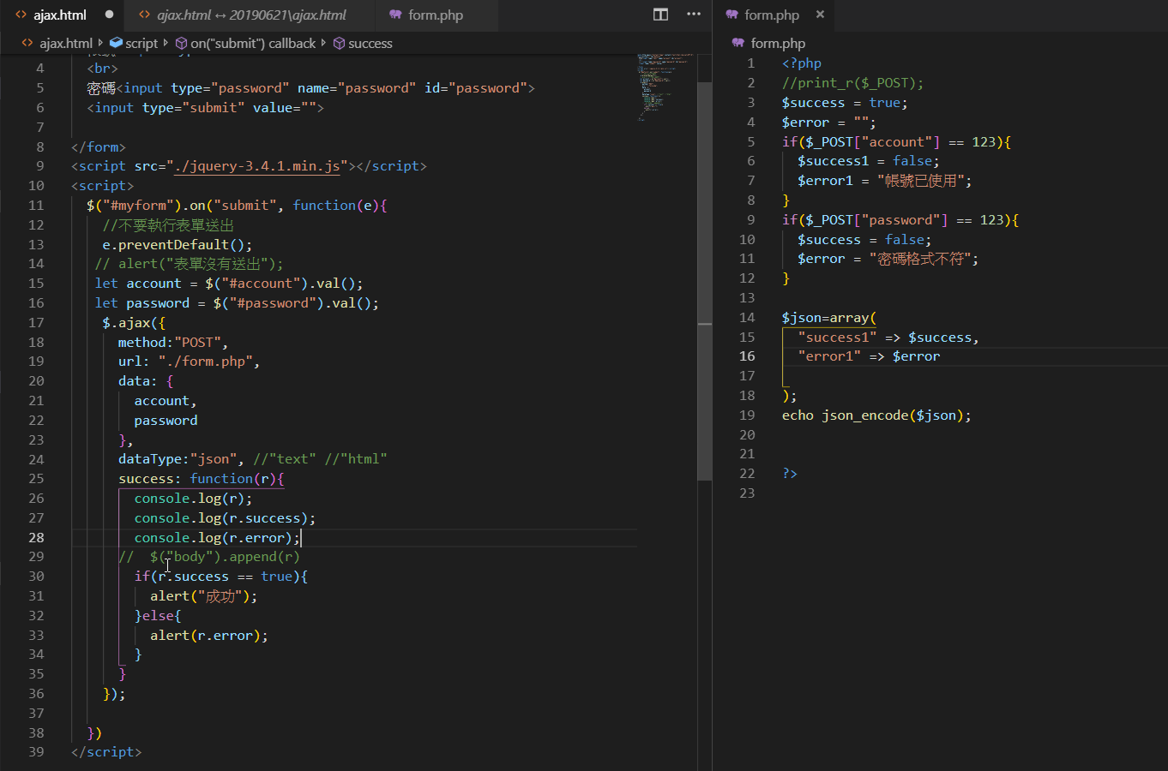

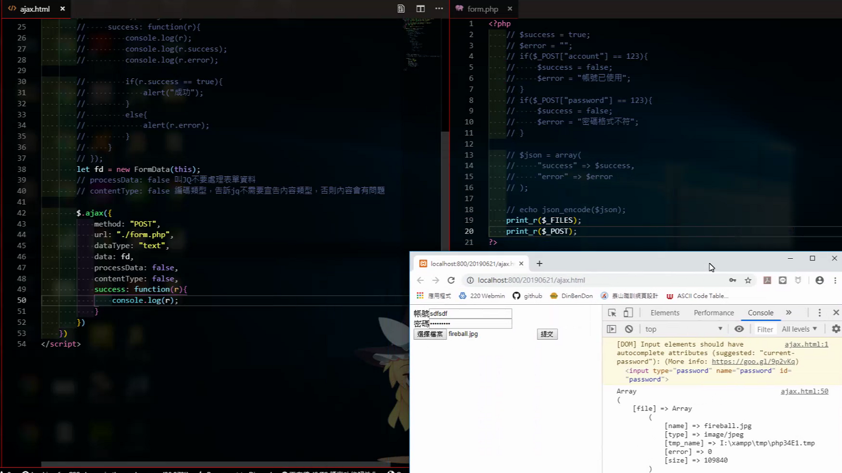

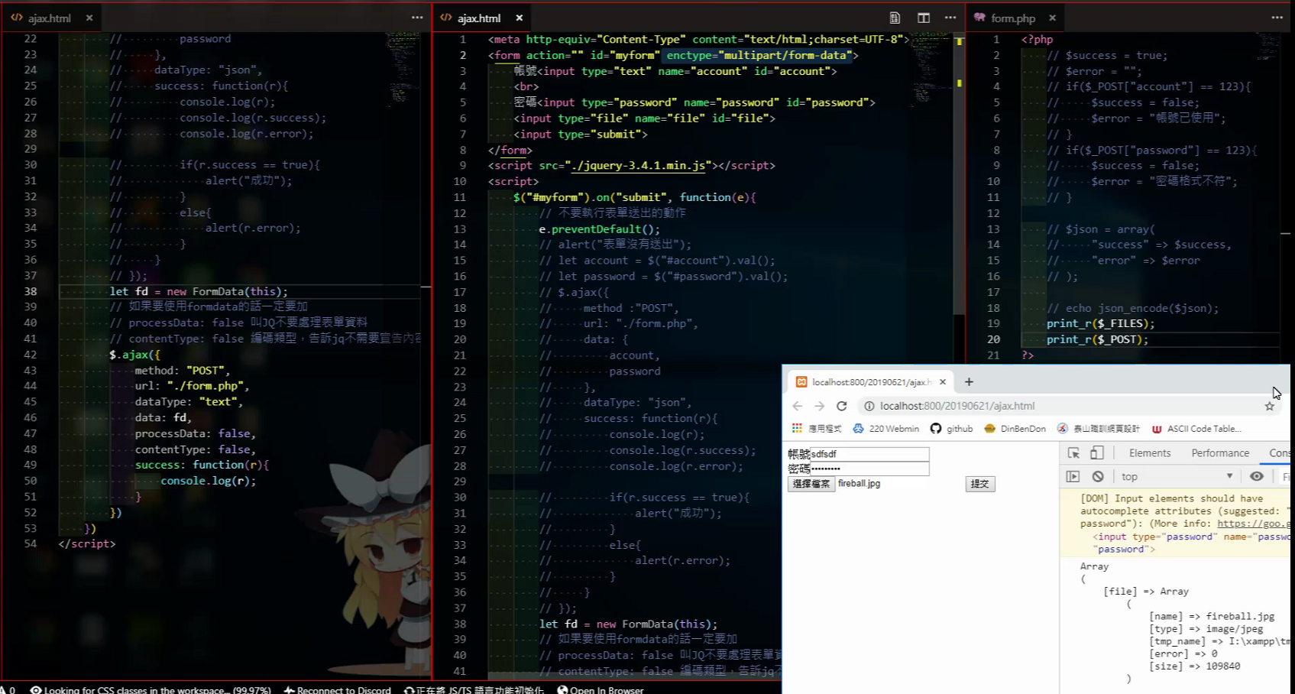

用let fd = new FormData(this);

data: fd,

的方式可以秀出表單內元件的內容

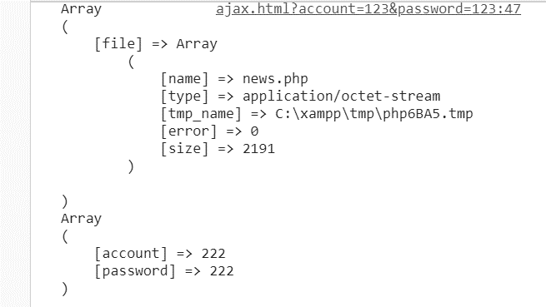

Ajax.html

<meta http-equiv="Content-Type" content="text/html;charset=UTF-8">

<form action="" id="myform" enctype="multipart/form-data">

帳號<input type="text" name="account" id="account">

<br>

密碼<input type="password" name="password" id="password">

<input type="file" name="file" id="file">

<input type="submit" >

</form>

<script src="./jquery-3.4.1.min.js"></script>

<script>

$("#myform").on("submit", function(e){

//不要執行表單送出

e.preventDefault();

let fd = new FormData(this);

//如果使用formdata的話一定要加

// processData:false 叫JQ不要處理表單資料

//contentType:false 編碼類型,告訴JQ不需要宣告內容

$.ajax({

method:"POST",

url: "./form.php",

data: fd,

processData: false,

contentType: false,

success: function(r){

console.log(r);

}

})

})

</script>

Form.php

<?php

print_r($_FILES);

print_r($_POST);

?>

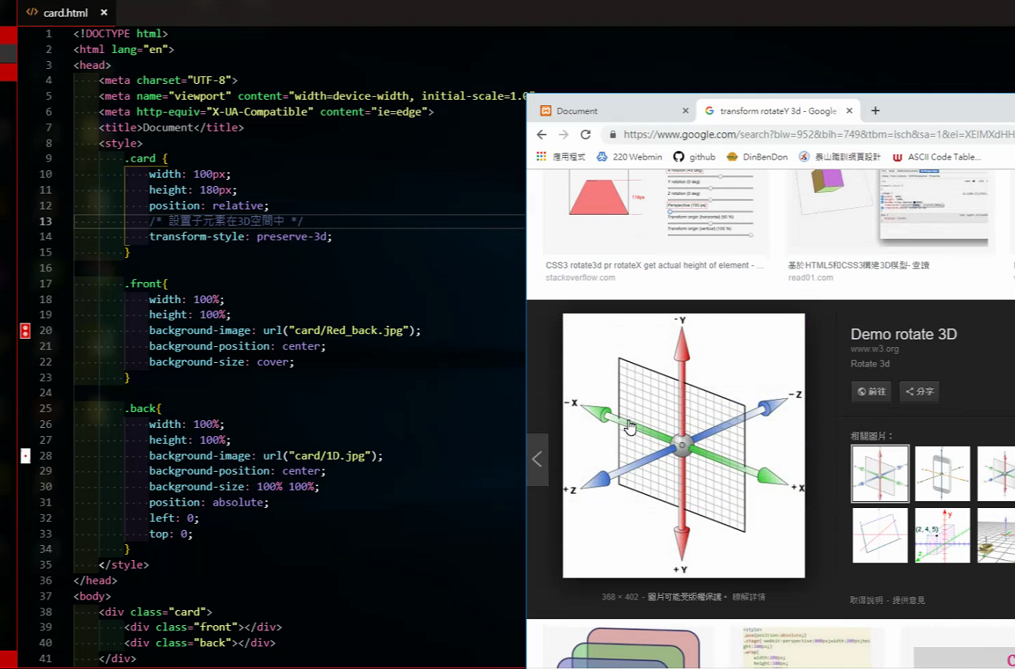

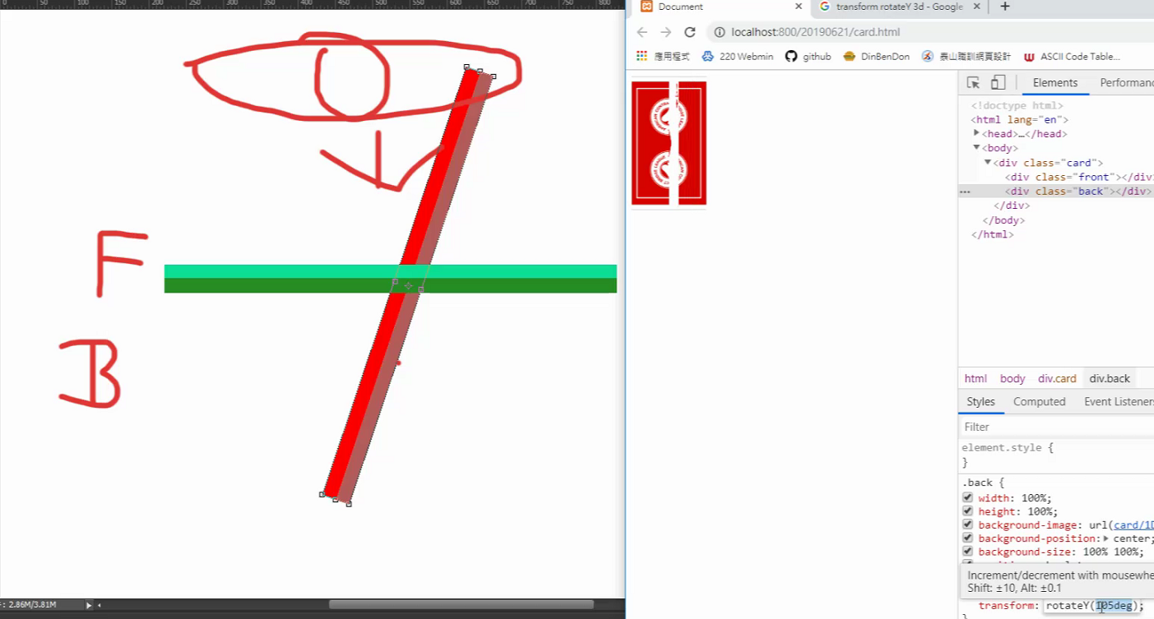

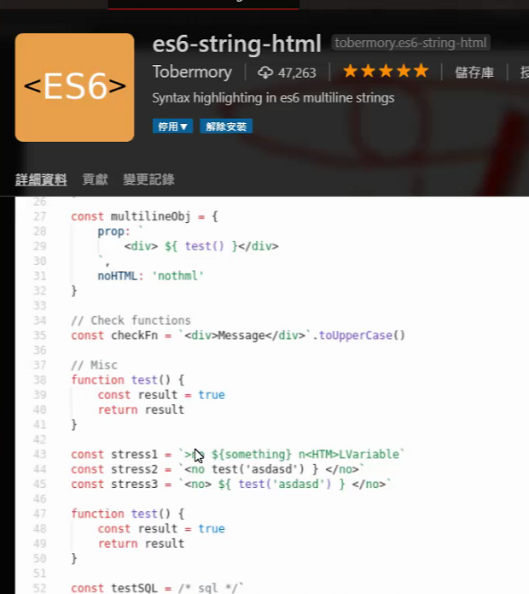

要安裝擴充套件

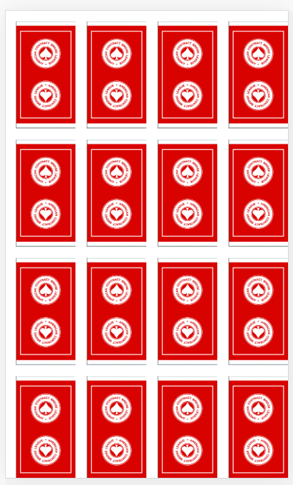

Card.html

<!DOCTYPE html>

<html lang="en">

<head>

<meta charset="UTF-8">

<meta name="viewport" content="width=device-width, initial-scale=1.0">

<meta http-equiv="X-UA-Compatible" content="ie=edge">

<title>Document</title>

<style>

.card{

width:100px;

height: 180px;

position: relative;

/*設置子元素在3D空間中*/

transform-style: preserve-3d;

transform: transform 0.5s;

float:left;

margin: 10px;

}

.front{

width:100%;

height: 100%;

background-image: url("./card/Red_back.jpg");

background-position: center;

background-size: cover;

}

.back{

width: 100%;

height: 100%;

background-image: url("./card/1D.jpg");

background-position: center;

background-size: 100% 100%;

position: absolute;

left :0;

top: 0;

transform: rotateY(180deg);

}

.open{

transform: rotateY(180deg);

}

#main{

width:500px;

}

</style>

</head>

<body>

<div id="main"></div>

<script src="./jquery-3.4.1.min.js"></script>

<script>

$(function(){

for(let i=0;i<16;i++){

$("#main").append( /* html */`

<div class="card">

<div class="front"></div>

<div class="back"> </div>

</div>` );

}

})

</script>

</body>

</html>

加這兩行,牌才會對齊,不然會變直的排列

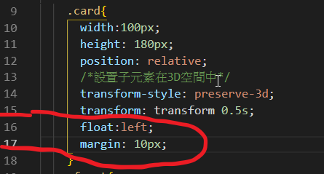

 

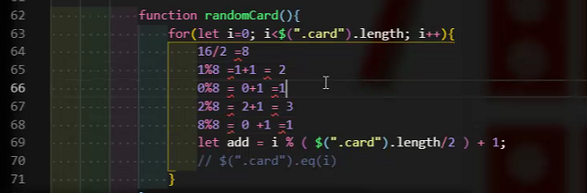

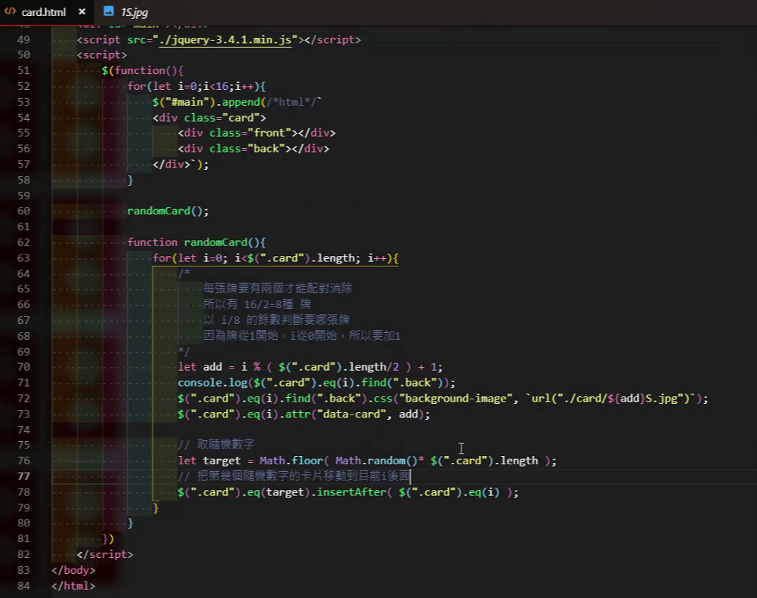

<https://pjchender.blogspot.com/2017/01/html-5-data-attribute.html>

